CST 415 – Lecture 5
Wilsonville, Fall 2017

CNP 3.2.3: Session, Presentation and Application Layers, HTTP part 1

Layers 5 through 7
Layer 5, Session – Control dialogs between applications involving multiple messages and connections
Layer 6, Presentation – Deals with different types of data serialized/deserialized and complex data types
Layer 7, Application – Abstraction of protocol used by applications

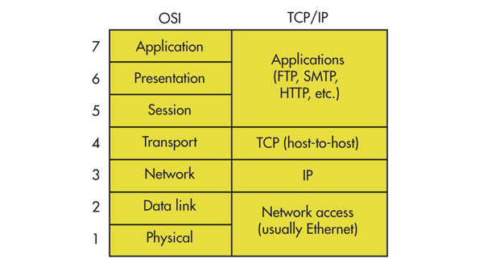
In the context of network applications…
- Session defines the dialog between two applications, typically over a single “connection”, involving multiple messages. A session protocol defines the expectations of both applications about what messages will be sent when, and in response to what other messages. In some protocols, sessions span multiple connections between the applciations (as in HTTP)
- Presentation defines the format of messages.
- Application is the highest level abstraction of service requests and responses.

For the modern internet, all three layers are grouped together and called “application protocols”.

Examples include Web (HTTP), Mail (SMTP) and File Transfer (FTP)

Web
Invented as a protocol for providing access to documents
Turned into the main protocol for the web

Initial components that led to successful adoption as the “world-wide web”:
- Unified document addressing scheme
- Common format for documents
- Standard protocol for retrieving documents from servers

URL – Uniform Resource Locator – standard for identifying documents
<scheme> : // <host> [: port] / <path> [? <query>] [ # <fragment>]

<scheme> - Protocol to use when requesting the resource, e.g. http, https, ftp
<host> - Server’s DNS name or IP address, with optional port, e.g. www.oit.edu:80
<path> - Location of the resource on the server
<query> - Parameters to pass to the resource
<fragment> - Index into the resource to pull back part, rather than all the content

HTML – HyperText Markup Language – standard format for web documents
Provides a way to present and view structured data
Includes “hyper-links” which can be URL’s for navigating to other documents

HTTP – Hyper Text Transfer Protocol – standard protocol for the web
More coming up next!

HTTP
Text based protocol for requesting and receiving web content
Implemented over TCP

HTTP request:
- Method URI Protocol/Version
- HTTP Header
- MIME document attachment (optional)

HTTP Response:
- Status
- HTTP Header
- MIME document attachment

Methods – variety available, most popular are GET and POST
GET – request a specific resource
POST – send an attached resource

Example GET request first line:
GET /MarkUp HTTP/1.0
Headers are one or more lines indicating information about the request or response, e.g.
Content-Length – length of document
Content-Type – type of document
Content-Encoding – encoding of document
Server – server initiating response
Date – date the request/response was generated
Last-Modified – when the document was last modified
User-Agent – client that generated the request
Host – server that the document is being requested from

Response status indicates server HTTP version, success/failure and reason as needed, e.g.
200 Ok
310 Moved Permanently
404 Not Found
500 Internal Server Error

Response header and content are separated by an empty line.

MIME stands for Multipurpose Internet Mail Extensions
It is a standard, well known, list of document types

Example (from CNP pg. 52):

Request:
GET / HTTP/1.0
User-Agent: curl/7.19.4 (universal-apple-darwin10.0) libcurl/7.19.4
OpenSSL/0.9.8l zlib/1.2.3
Host: www.ietf.org

Response:
HTTP/1.1 200 OK
Date: Mon, 15 Mar 2010 13:40:38 GMT
Server: Apache/2.2.4 (Linux/SUSE) mod_ssl/2.2.4 OpenSSL/0.9.8e
Last-Modified: Tue, 09 Mar 2010 21:26:53 GMT
Content-Length: 17019
Content-Type: text/html

<!DOCTYPE HTML PUBLIC .../HTML>

HTTP uses TCP as the Transport layer
Initially the client and server sent only a single request/response during one connection
Given overhead of loading many embedded resources in a single HTML document, changed to allow multiple request/response within single connection

Headers that allow multiple request/response on a single connection:
Connection: keep-alive keep connection open for next request
Connection: close close after responding to this request

HTTP Session
Unifies a user’s use of a web site across multiple connections
Facilitated by cookies… data stored on client and sent back to server with each request…
Cookie: send cookie to the server with request
Set-Cookie: tell client through response to keep this cookie

